Using the ePledge Administrator Portal

Campaign Management:

The CAMPAIGN MANAGEMENT tab can provide a brief snapshot of campaign information (or view in the dashboard---see REPORTS), and also allows users to attach documents such as email messaging and updated logos to be used during their campaign.

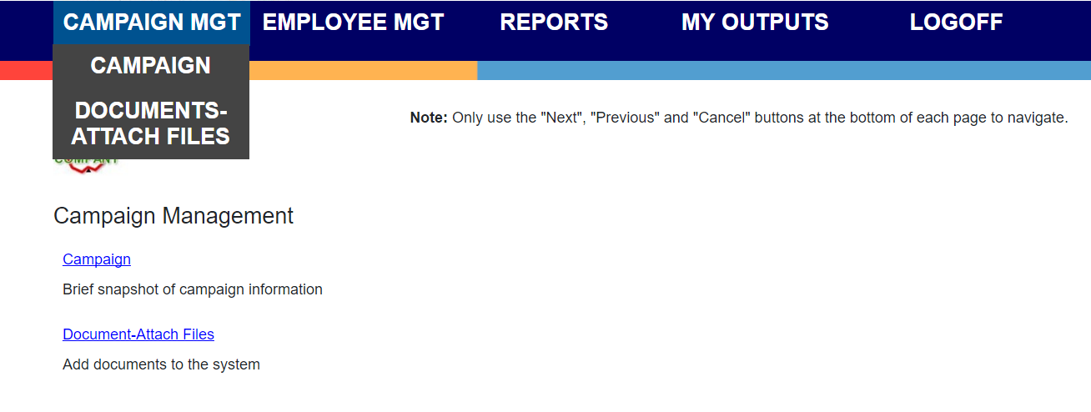

Employee Management:

Under the EMPLOYEE MGT tab, the EMPLOYEE LIST tab will allow you to search for an existing employee, and ADD employees. Please DO NOT ADD new employees here. Contact donor.services@unitedwaytoledo.org to add a new employee, as additional programming is required to properly set up an employee for ePledge.

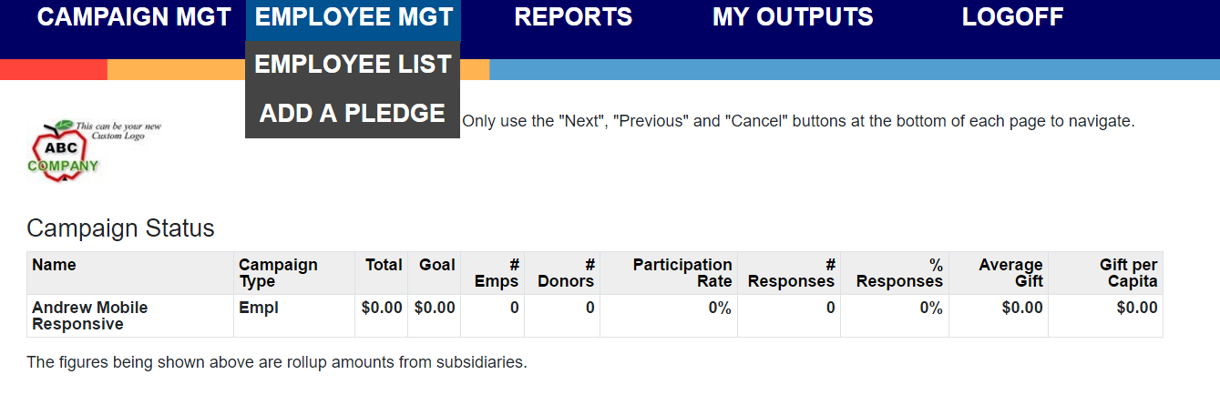
The ADD A PLEDGE tab can be used to SEARCH an individual record. If an employee is missing their confirmation email, and wants to know if their pledge was recorded, the campaign manager can use this tab to see the status of their pledge. Retrieve the individual’s record here, and their pledge can be viewed to see if it has been completed, and resend their confirmation email if needed. If an employee needs assistance pledging, you could also enter a pledge for them as an administrator, or enter pledge cards from this tab.

E-Pledge Reports:
The Campaign Manager and RD will have access to all the ePledge reports.

- CASH REPORT: Provides a list of all cash and check donors from the specified organization and identifies whether funds have been received by the company and/or fundraiser. Should be run by the CM on the last day of campaign in order to provide a check list of the cash and check payments to collect.
- NO RESPONSE REPORT: Provides a list of individuals who have not yet donated at the organization. If you check the box “include amounts”, it will have the previous year’s gift in the report for anyone who gave last year and hasn’t renewed their pledge. It is a very quick way to get a list of outstanding donors, and identify outstanding Leadership donors.
- RESPONSE REPORT: Provides a list of all donors
- TRANSACTION REPORT: All transactions created for the account are recorded as a line entry on this report. Amounts are always displayed with the transaction data.

The Campaign Manager can access these reports from their ePledge account. Login to ePledge, then select the “Change to Administrator” option at the bottom left of the home page. The Administrator page displays a campaign status table with current statistics (screen shot below.)

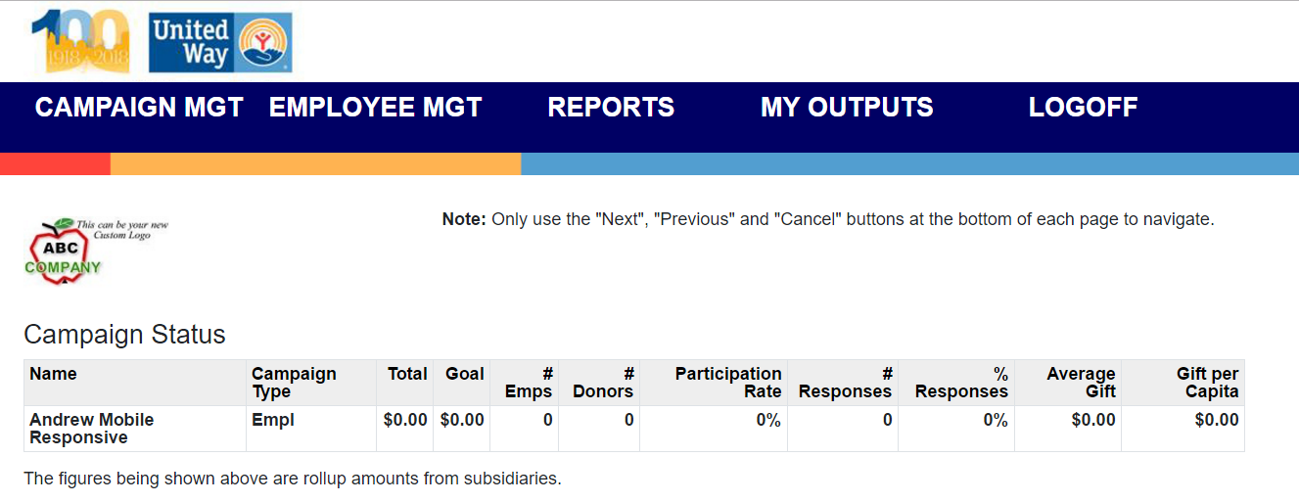
Selecting the REPORTS tab on the Administrator portal will allow the CM to select the report type they wish to run from the dropdown menu. Once the report is complete, it will auto-load to the MY OUTPUTS tab. User must select MY OUTPUTS to view the report.

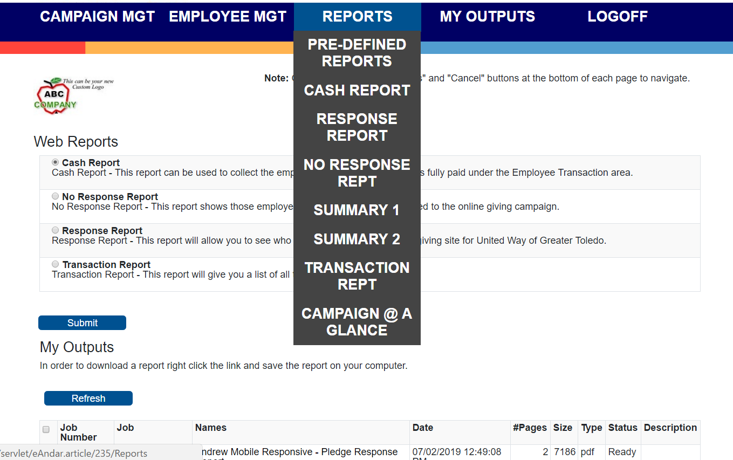

Selecting the first report option PRE-DEFINED REPORTS will allow the CM to run the four most common reports and view their results within the same screen, instead of toggling to MY OUTPUTS.
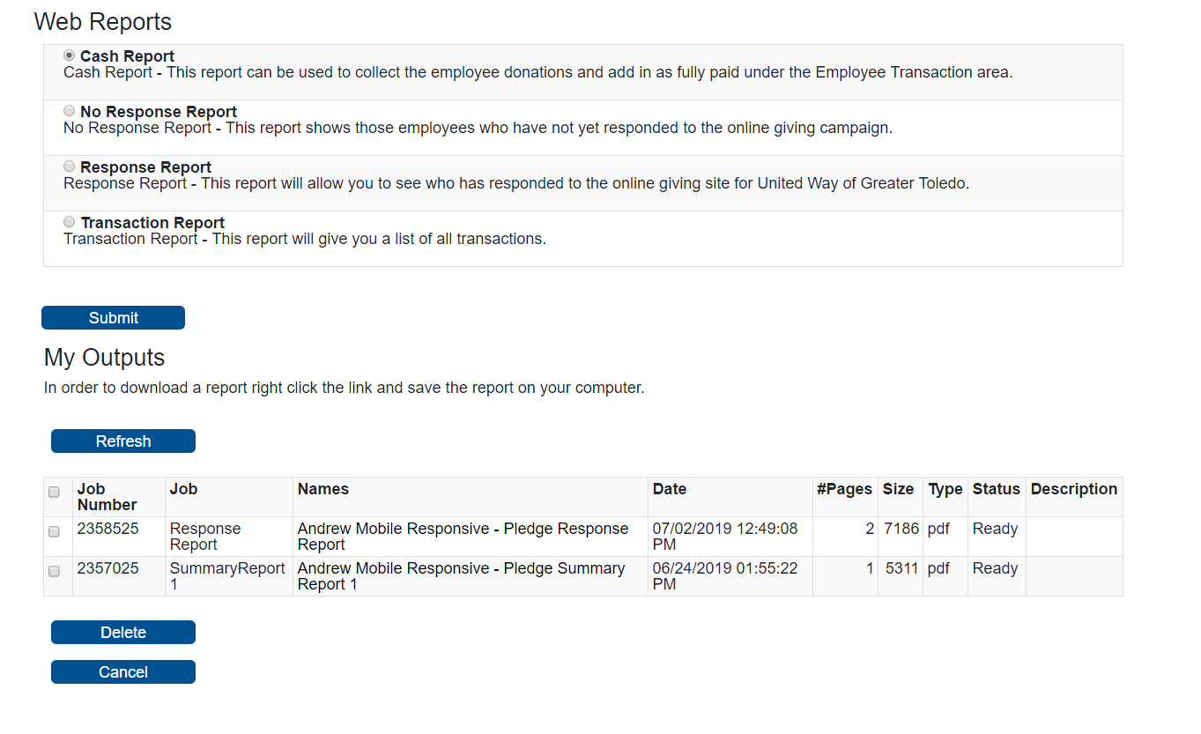
CAMPAIGN @ A GLANCE

New in 2016, CAMPAIGN @ A GLANCE is an easy to read dashboard, with the most requested campaign details all in one place. This is the perfect option for a CM to easily assess campaign progress. It provides a detailed, easy to read snapshot of campaign statistics. To view, select the last option under the reports tab (see below.) Then click on the company name (ie. “Andrew Mobile Response”) for local only campaigns or ‘Roll-up’ for campaigns with multiple locations.

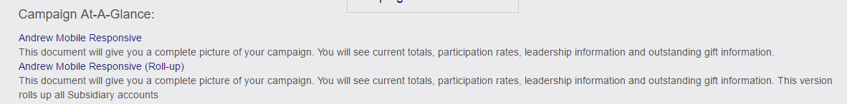

Below is an example of the CAMPAIGN @ A GLANCE Dashboard:
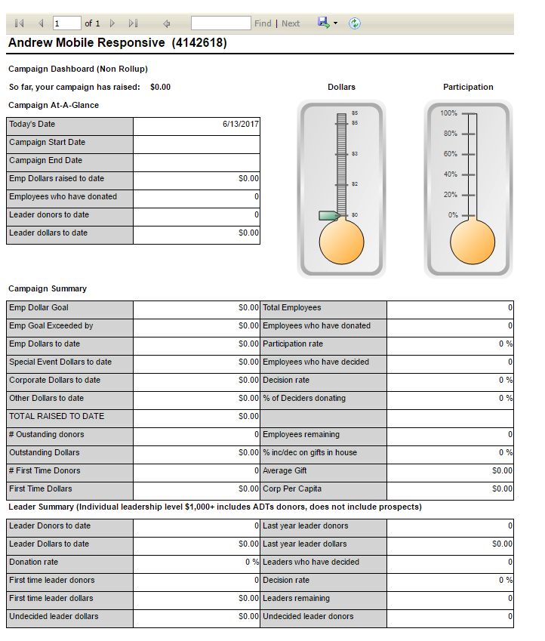

FAQ:
Q: How do I look at all gifts received? What type of gift are they? Were they designated to an agency and which one?
A: Run the Transaction report and include donor detail. This will allow you to view this information for everyone at the organization you run the report for.
Q: How do I view outstanding leadership givers?
A: Run the No Response report including amounts as a .csv file, and when you receive the output sort by last year’s gift. Anyone that has a last year’s gift of $1000 or more on that report is an outstanding leader.
Q: Can we track Special Events and Corporate gifts?
A: No. ePledge does not show Special Events or Corporate Gifts. It is strictly for tracking employee pledges.
Q: Is there a minimum gift required in order to use ePledge?
A: At this time, there is no minimum gift requirement.
Q: What is Quick pledge and why is it beneficial to our campaign?
A: Quick Pledge is a faster way to make a payroll gift through ePledge. With one click, a donor confirms their payroll gift at a percentage increase over last year’s gift, or a set amount per pay period (for new donors). This one-click pledge secures a gift with a built-in increase for gifts designated to the United Way Community Fund.

